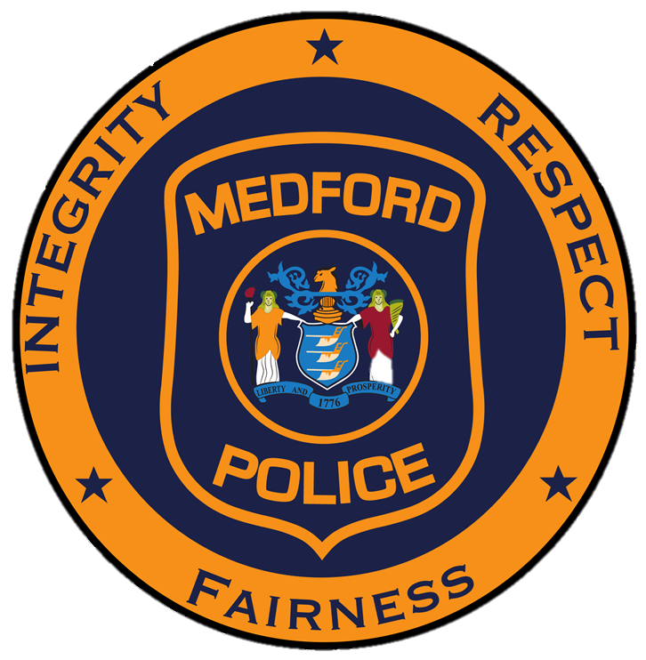
Township of Medford
Division of Police
91 Union Street, Medford, New Jersey 08055
609-654-7511 main 609-654-5996 fax

Arthur E. Waterman
Chief of Police

For More Information: For Immediate Release:
Lt. James D’Averso April 3, 2024
Public Information Officer
609-654-7511, ext. 160

Motor Vehicle Crash with Injuries

On April 2, 2024 at 12:51PM, Medford Police, Fire, and EMS responded to the intersection of Route 70 and County Route 541(Medford Mt. Holly Road) for a motor vehicle crash with injuries. The on-scene investigation determined Christina Welch, age 86, of Squirrel Road Marlton NJ, was travelling east on Route 70 operating her 2008 Ford Focus attempting to make a left turn onto Medford Mt. Holly Road as Sandra Agathokleous, age 78, of Dunstable Road Southampton NJ, was travelling west on Route 70 operating her 2009 Chevy Cobalt. The two vehicles impacted within the intersection causing the Chevy Cobalt to impact a 2024 Mercedes Benz being operated by David York, age 56, of Medford Mt. Molly Road Medford, NJ. As a result of the crash, Christina Welsh and Sandra Agathokleous were transported to Cooper University Hospital for additional medical treatment. Currently this crash is under investigation by the Medford Township Police Department Traffic Unit.

