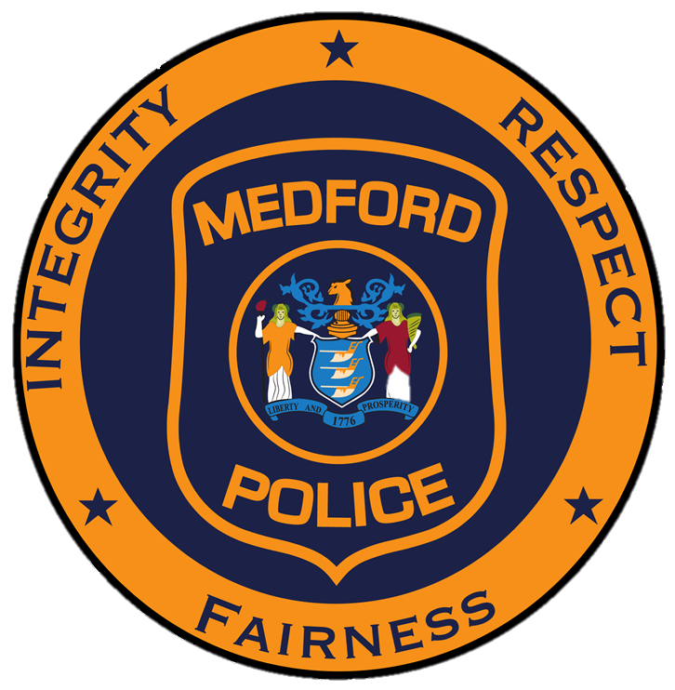
Township of Medford
Division of Police
91 Union Street, Medford, New Jersey 08055
609-654-7511 main 609-654-5996 fax

Arthur E. Waterman
Chief of Police

For More Information: For Immediate Release:
Lt. James D’Averso DATE: March 21, 2024
Public Information Officer
609-654-7511, ext. 160

Motor Vehicle Crash with Injuries

On March 20, 2024 at 8:04PM, the Medford Township Police, Fire and EMS Departments responded to the intersection of Route 70 and Eayrestown Road for a report of a motor vehicle crash with injuries. The on-scene investigation determined that Cynthia Friedberg, age 77, Lincondate Court Medford, NJ was traveling south on Eayrestown Road operating her 2024 Cadillac CT5. While continuing through the intersection, Katherine Dejneka, age 63, North Giles Avenue Chatsworth, NJ was operating her 2011 Hyundia Elantra traveling east on Route 70 and impacted Friedberg’s vehicle. As a result of the impact, Dejneka sustained injuries to her chest and neck and was transported to Virtua Mount Holly Hospital for additional medical treatment. This on-going crash investigation is assigned to the Medford Township Police Department Traffic Unit.

